WEEK-13-PASSING ARRAYS AND STRING TO FUNCTIONS

WEEK-13-passing arrays and strings to functions

Reg no:241801289

Name;Tamilselvan.k

Q1

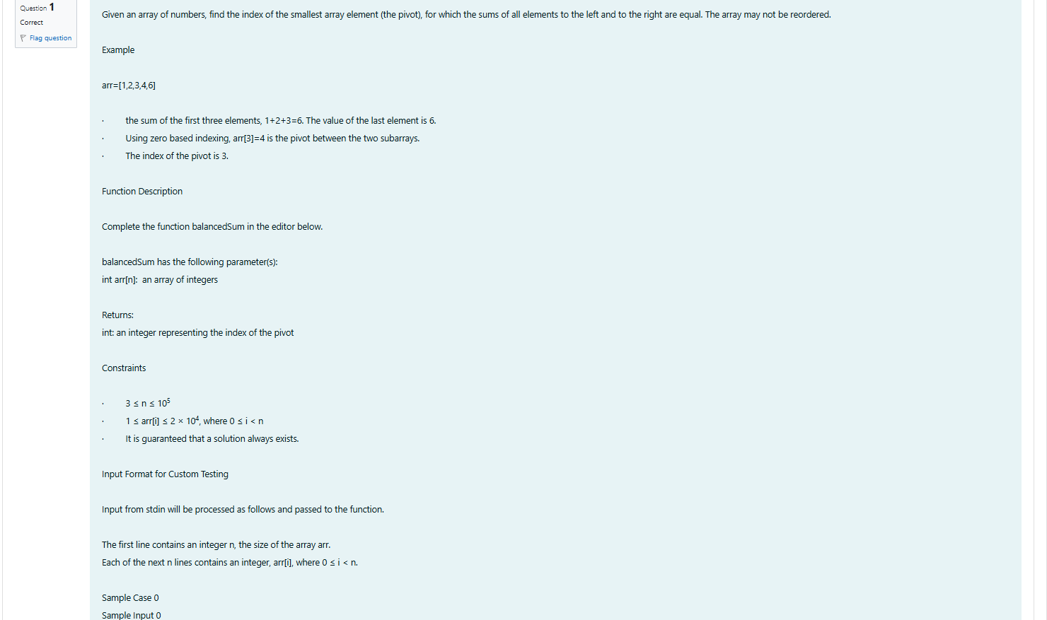

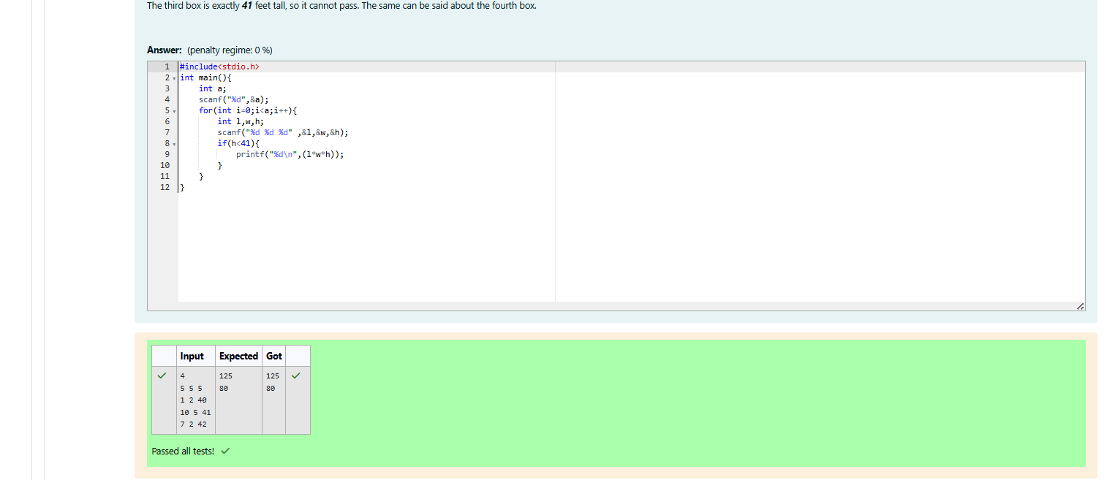

WEEK-13-passing arrays and strings to functions

Reg no:241801289

Name;Tamilselvan.k

Q2

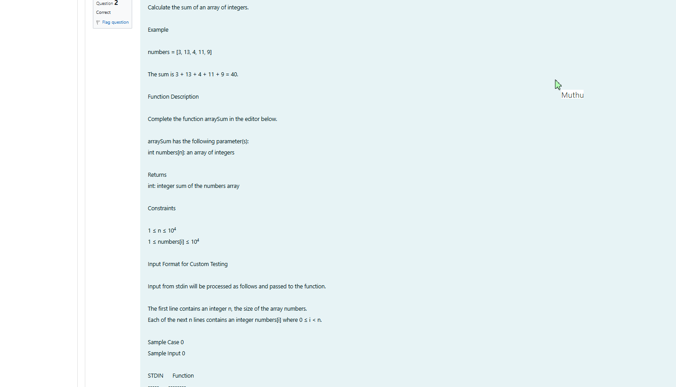

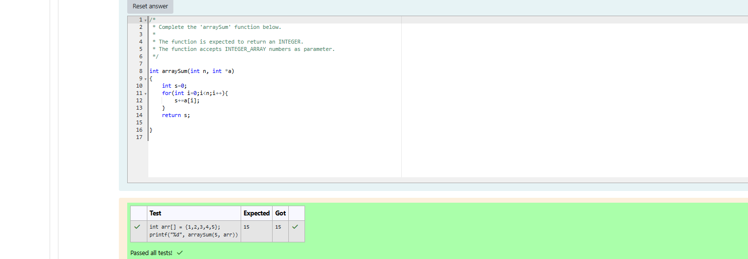

WEEK-13-passing arrays and strings to functions

Reg no:241801289

Name;Tamilselvan.k

Q3

